Table of Contents

Schematic diagrams 2

Some Basic Concepts related to Power Supplies 4

Transformers 4

Voltage Regulators 5

Diode Bridge 5

Filter Circuit 6

How the power supply circuit works 6

The Torch light with multiple LED…………………………………………………………………………………………………………….7

SHORT NOTES ON INDIVIDUAL ITEMS ON THE CIRCUIT BOARD 7

THE VEROBOARD 7

Printed circuit board (PCB) 9

Resistors 10

Capacitors 10

Diodes 11

Light-Emitting Diodes 11

**Transistors** 12

Integrated Circuits 12

**Soldering** 15

**Desoldering** 16

ITEMS REQUIRED

* Piece of veroboard
* Four 1N4001 diodes
* LM7812 regulator
* Transformer that has an output of 14v - 35v AC with an output current between 100mA to 1A, depending how much power you will need. (I found a 16v 200mA transformer in a broken alarm clock.)
* 1000uF - 4700uF capacitor
* 1uF capacitor
* Two 100nF capacitors
* Five 221Ω resistors
* Twenty white LEDs
* Jumper wires (I used some plain wire as jumper wires)
* Heatsink (optional)
* Soldering iron
* Wire cutters
* Wire strippers
* A thing you can cut veroboard tracks.
* Hot glue (To hold components down and make the power supply physically strong and sturdy.

Schematic diagrams



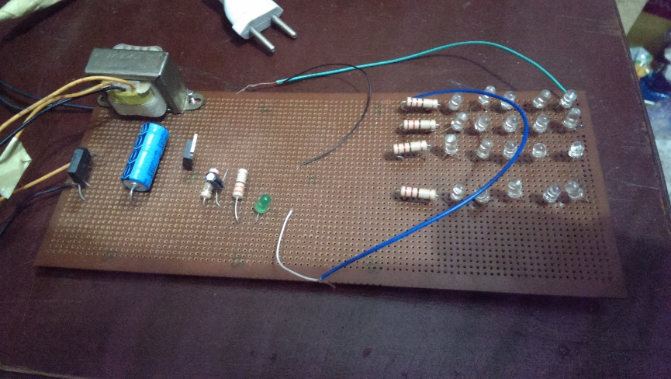

Theory on 12volts power supply circuits.

What is a power supply?

A power supply is a device which delivers an exact voltage to another device as per its needs.

There are many power supplies available today in the market like regulated, unregulated, variable etc, and the decision to pick the correct one depends entirely on what device you are trying to operate with the power supply. Power supplies, often called power adapters, or simply adapters, are available in various voltages, with varying current capacities, which is nothing but the maximum capacity of a power supply to deliver current to a load (Load is the device you are trying to supply power to).

Items required

1. Copper wires, with at least 1A current carrying capacity for AC mains
2. Step Down Transformer
3. 1N4007 Silica Diodes (×4)
4. 1000µF Capacitor
5. 10µF Capacitor
6. Voltage regulator (78XX) (XX is the output voltage reqd. I’ll explain this concept later)
7. Soldering iron
8. Solder
9. General Purpose PCB
10. Adapter jack (to provide the output voltage to a device with a particular socket)
11. 2 Pin plug

Optional

1. LED (for indication)
2. Resistor (Value explained later)
3. Heat Sink for The Voltage Regulator (For higher current outputs)
4. SPST Switch

# Some Basic Concepts related to Power Supplies

Transformers

Transformers are devices which step down a relatively higher AC input Voltage into a lower AC output voltage

I/O Terminals of a Transformer

Basically, there are two sides in a transformer where the coil winding inside the transformer ends. Both ends have two wires each (unless you are using a center-tapped transformer for full wave rectification). On the transformer, one side will have three terminals and the other will have two. The one with the three terminals is the stepped down output of the transformer, and the one with the two terminals is where the input voltage is to be provided.

Voltage Regulators

The 78XX series of voltage regulators is a widely used range of regulators all over the world. The XX denotes the voltage that the regulator will regulate as output, from the input voltage. For instance, 7805, will regulate the voltage to 5V. Similarly, 7812 will regulate the voltage to 12V. The thing to remember with these voltage regulators is that they need at least 2 volts more than their output voltage as input. For instance, 7805 will need at least 7V, and 7812, at least 14 volts as inputs. This excess voltage which needs to be given to voltage regulators is called Dropout Voltage.

NOTE: The input pin is denoted as ‘1’, ground as ‘2’ and output as ‘3’.

Voltage Regulator Schematic

Voltage Regulator Schematic

Diode Bridge

A bridge rectifier consists of an assembly of four ordinary diodes, by means of which we can convert AC Voltage into DC Voltage. It is found to be the best model for AC to DC conversion, over Full wave and Half wave rectifiers. You can use any model you want, but I use this for the sake of high efficiency (If you are using the full wave rectifier model, you’ll need a center-tapped transformer, and you will only be able to use half of the transformed voltage).

One thing to note about diodes is that they drop about 0.7V each when operated in forward bias. So, in bridge rectification we will drop 1.4V because at one instant two diodes are conducting and each will drop 0.7V. In case of Full wave rectifier, only 0.7V will be dropped.

So how does this drop affect us? Well, this comes in handy while choosing the correct step down voltage for the transformer. See, our voltage regulator needs 2 Volts more than its output voltage. For the sake of explanation, let’s assume that we are making a 12V adapter. So the voltage regulator needs at least 14 Volts as input. So the output of the diodes (which goes into the voltage regulator) will have to be more than or equal to 14 Volts. Now for the diodes’ input voltage. They’ll drop 1.4 Volts in total, so the input to them has to be greater than or equal to 14.0 + 1.4 = 15.4Volts. So I would probably use a 220 to 18 Volt step down transformer for that.

So basically, the transformer step down voltage should be at least 3.4V more than the desired Power Supply output.

Schematic and Illustration of a Diode

Schematic and Illustration of a Diode

Filter Circuit

We filter, both the input and output of the voltage regulator in order to get the smoothest DC Voltage as possible, from our adapter, for which we use capacitors. Capacitors are the simplest current filters available, they let AC current pass through and block DC, so they are used in parallel to the output. Furthermore, if there is a ripple in the input or output, a capacitor rectifies it by discharging the charge stored in it.

How the power supply circuit works

The AC mains are fed to the transformer, which steps down the 230 Volts to the desired voltage. The bridge rectifier follows the transformer thus converting AC voltage into a DC output and through a filtering capacitor feeds it directly into the input (Pin 1) of the voltage regulator. The common pin (Pin 2) of the voltage regulator is grounded (but in our case, it was not grounded). The output (Pin 3) of the voltage regulator is first filtered by a capacitor, and then the output is taken.

Make the circuit on a general purpose PCB and use a 2 Pin (5A) plug to connect the transformer input to the AC mains via insulated copper wires.

If you want to power up a device you bought from the market, you need to solder your Power supply output to an adapter jack. This adapter jack comes in a variety of shapes and sizes and completely depends on your device. If you want to power up a self made circuit or device, then you would probably run the output wires of your supply into your circuit directly.

An important thing to note is that you will need to take care of the polarities, while using this supply, as most of the devices you will power up will only work on forward bias, and will not have an inbuilt rectifier to correct wrong polarities.

Connection ports of an Adapter Jack

Almost all of the devices will need positive on the tip, and ground on the sleeve, except a few, for example, in the music industry, almost all the devices will need ground on the tip, and positive on the sleeve.

# SHORT NOTES ON INDIVIDUAL ITEMS ON THE CIRCUIT BOARD

## THE VEROBOARD

As with other stripboards, in using Veroboard, components are suitably positioned and soldered to the conductors to form the required circuit. Breaks can be made in the tracks, usually around holes, to divide the strips into multiple electrical nodes enabling increased circuit complexity.

[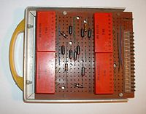](http://en.wikipedia.org/wiki/File:1960_VB_PRODUCT_-_comps.JPG)

1961 Veroboard unit - components

[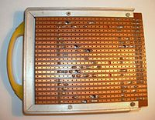](http://en.wikipedia.org/wiki/File:1960_VB_PRODUCT_-_copper.JPG)

1961 Veroboard unit - copper

This type of wiring board may be utilised for initial electronic circuit development, to construct [prototypes](http://en.wikipedia.org/wiki/Prototypes) for bench testing or in the production of complete electronic units in small quantity. Veroboard was first used for prototype construction within Vero Electronics Department in 1961. The images of a [binary](http://en.wikipedia.org/wiki/Binary_number) decade [counter](http://en.wikipedia.org/wiki/Counter_(digital))sub-unit clearly show both the assembled components and the copper conductors with the required discontinuities.

[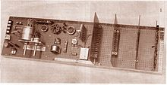](http://en.wikipedia.org/wiki/File:1961_VEROBOARD_Assembly.jpg)

1961 Veroboard Display Board

A number of these sub-units were interconnected through connectors mounted on a motherboard similar to that shown in the Veroboard Display image and perhaps comprised a very early PCB-based [backplane](http://en.wikipedia.org/wiki/Backplane)system. It may be of interest to note that each sub-unit had a digital capacity equivalent to 1/2 [byte](http://en.wikipedia.org/wiki/Byte) of [data storage](http://en.wikipedia.org/wiki/Computer_data_storage) - ie 2,000,000 would be required to store 1[Megabyte](http://en.wikipedia.org/wiki/Megabyte).

Two forms of Veroboard are produced with hole pitch of 2.5mm (0.1in) or 3.5mm (0.15in). The larger pitch is and was considered easier to assemble, especially at a time when many constructors were still more familiar with [valves](http://en.wikipedia.org/wiki/Vacuum_tube) and tag strips. The increasingly popular [integrated circuits](http://en.wikipedia.org/wiki/Integrated_circuit) in [dual in-line packages](http://en.wikipedia.org/wiki/Dual_in-line_package) would only fit the 0.1 boards. Very soon 0.1 pitch became by far the dominant form. Integrated circuits and the common layout of short parallel strips radiating from the sides of an IC package encouraged the development of specialist boards such as Verostrip. This was a long, thin board with the copper strips arranged transversely, rather than the usual lengthwise. A ready-cut central gap was provided to isolate the sides of the IC.

## Printed circuit board (PCB)

A printed circuit board (PCB) mechanically supports and electrically connects [electronic components](http://en.wikipedia.org/wiki/Electronic_component) using [conductive](http://en.wikipedia.org/wiki/Electrical_conductor) tracks, pads and other features [etched](http://en.wikipedia.org/wiki/Industrial_etching) from copper sheets [laminated](http://en.wikipedia.org/wiki/Laminated) onto a non-conductive [substrate](http://en.wikipedia.org/wiki/Substrate_(electronics)). PCBs can be single sided (one copper layer), double sided (two copper layers) or multi-layer (outer and inner layers). Multi-layer PCBs allow for much higher component density. Conductors on different layers are connected with plated-through holes called [vias](http://en.wikipedia.org/wiki/Via_(electronics)). Advanced PCBs may contain components - capacitors, resistors or active devices - embedded in the substrate.

Printed circuit boards are used in all but the simplest electronic products. Alternatives to PCBs include [wire wrap](http://en.wikipedia.org/wiki/Wire_wrap) and [point-to-point construction](http://en.wikipedia.org/wiki/Point-to-point_construction). PCBs require the additional design effort to lay out the circuit, but manufacturing and assembly can be automated. Manufacturing circuits with PCBs is cheaper and faster than with other wiring methods as components are mounted and wired with one single part. Furthermore, operator wiring errors are eliminated.

When the board has only copper connections and no embedded components, it is more correctly called a printed wiring board (PWB) or etched wiring board. Although more accurate, the term printed wiring board has fallen into disuse. A PCB populated with electronic components is called a printed circuit assembly (PCA), printed circuit board assembly or PCB assembly (PCBA). The [IPC](http://en.wikipedia.org/wiki/IPC_(electronics)) preferred term for assembled boards is circuit card assembly (CCA),[[1]](http://en.wikipedia.org/wiki/Printed_circuit_board#cite_note-1) and for assembled [backplanes](http://en.wikipedia.org/wiki/Backplane) it is backplane assemblies. The term PCB is used informally both for bare and assembled boards.

Resistors

A resistor is a component that resists the flow of current. It's one of the most basic components used in electronic circuits. If you put resistors next to a penny, you get an idea of how small they are.

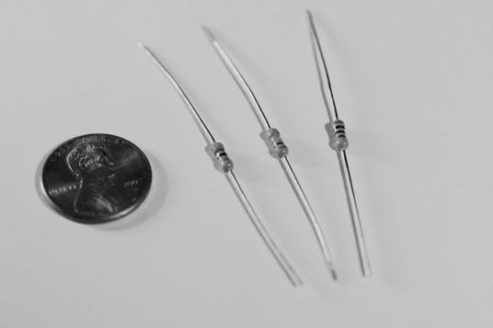

Resistors come in a variety of resistance values (how much they resist current, measured in units called ohms and designated by the symbol Ωandpower ratings (how much power they can handle without burning up, measured in watts).

Capacitors

Next to resistors, capacitors are probably the second most commonly used component in electronic circuits. A capacitor is a device that can temporarily store an electric charge.

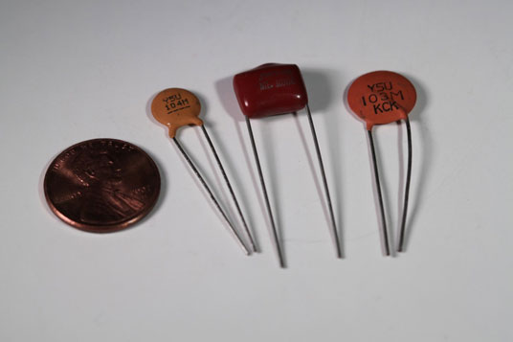

Capacitors come in several different varieties, the two most common beingceramic disk and electrolytic. The amount of capacitance of a given capacitor is usually measured in microfarads, abbreviated μF.

Diodes

A diode is a device that lets current flow in only one direction. A diode has two terminals, called the anode and the cathode. Current will flow through the diode only when positive voltage is applied to the anode and negative voltage to the cathode. If these voltages are reversed, current will not flow.

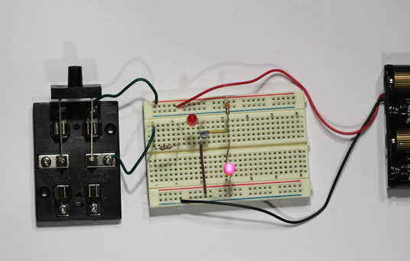

Light-Emitting Diodes

A light-emitting diode (or LED) is a special type of diode that emits light when current passes through it.

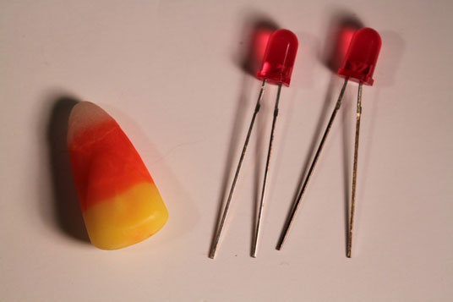

## **Transistors**

A transistor is a three-terminal device in which a voltage applied to one of the terminals (called the base) can control current that flows across the other two terminals (called the collector and the emitter). The transistor is one of the most important devices in electronics.

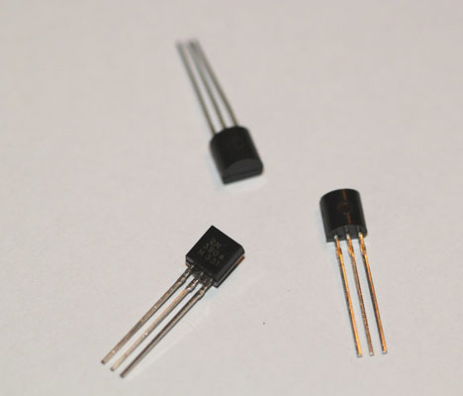

Integrated Circuits

An integrated circuit is a special component that contains an entire electronic circuit, complete with transistors, diodes, and other elements, all photographically etched onto a tiny piece of silicon. Integrated circuits are the building blocks of modern electronic devices such as computers and cellphones.

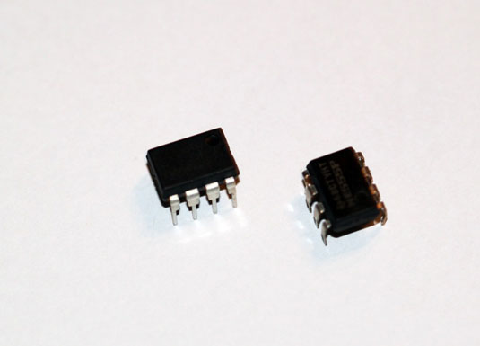

Rectification and filtration

What is rectification?

It is the process of obtaining unidirectional current and voltage from alternating currents and voltages. Without rectification, appliances plugged into a power source would simply get damaged. This is because, voltage must never vary with time, but must remain constant at all times.

**Diagram illustrating the varying voltage with time in an AC**

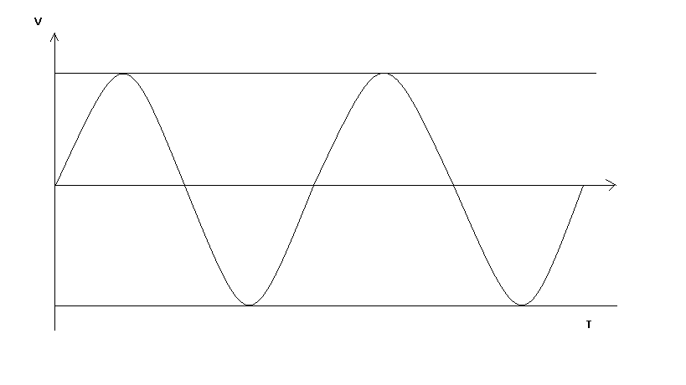

When the ac current is passed into a rectification circuit, the diodes in the circuit, which only permitts the flow of current in one direction, and only goes on when voltage is positive, eliminates the negative parts of the wave form as shown below;

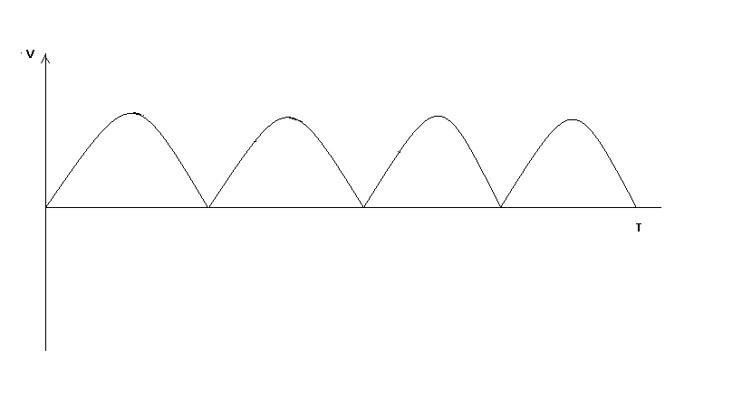

Next, due to the Capacitor in the rectification circuit, at points where the diode turns of, the capacitor **dissipates current exponentially. This serves as a low pass filter** dissipating current evenly, till the diode turns on again. The resulting effect on the wave form is shown as follows:

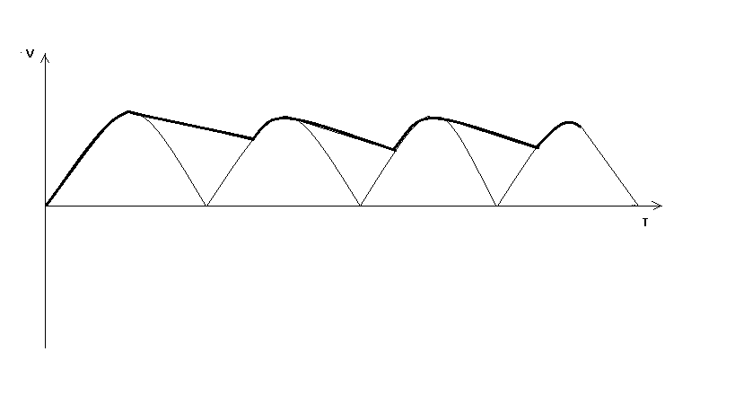

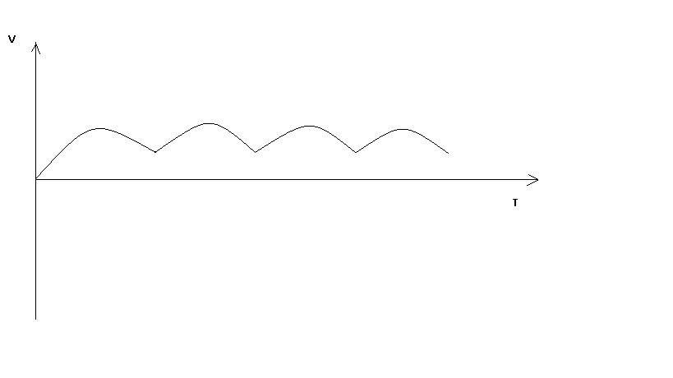

Diagram illustrating the fully rectified voltage.



# **Soldering**

Soldering is the process of using a filler material (solder) to join pieces of metal together. Soldering occurs at relatively low temperatures (around 400 degrees Fahrenheit) as compared to brazing and welding, which actually melt and fuse the materials themselves at higher temperatures. In soldering the filler material becomes liquid, coats the pieces it is brought into contact with, and is then allowed to cool. As the solder cools it hardens, and the two materials are joined. Soldering is a quick way to join many types of materials, from copper pipe to stained glass. It creates an electrically conductive strong bond between components that can be re-heated (desoldered) if you should ever want to disconnect two items joined together. It's great for joining electrical components and wires and is used in just about everything electronic.

**Desoldering**

Desoldering is the process of removing solder at a joint to disconnect two components, wires or materials. You might have to do this if you want to replace a component that's gone bad, or if you want to change something about your design once it's already soldered into place. To desolder wires you can usually just heat up the connection and wiggle them around until they come free. Better yet, if you have the slack, just cut the wire at the connections, strip, and resolder as necessary.   
  
With leads that are mounted through holes on a circuit board it takes a little more finesse. To desolder something delicate it’s best to use a desoldering pump, or bulb which will actually suck up the molten solder and remove it from the joint. Soldering wicks or braided copper wire also work well to suck up unwanted solder.

**A TECHNICAL REPORT ON A POWER SUPPLY AND A TORCH WITH MULTIPLE LEDs**

**ELECTRICAL ELECTRONICS GROUP 2**

**EJIMONU KOSISOCHUKWU GABRIEL -13/ENG04/013 (GROUP LEADER)**

**FAKEYE KEHINDE AYOKUNLE -13/ENG04/014**

**CHUKWU PROMISE -13/ENG04/011**

**CHUMA-NWOSU AFAMEFUNA -13/ENG/04/012**

**ASUQUO UNYIMEABASI -13/ENG02/008**

**CHIJIOKE CHIEMELIE MARIUS-LEO -13/ENG04/010**

**COLLEGE: ENGINEERING**

**SUBMITTED TO THE DEPARTMENT OF**

**ELECTRICAL ELECTRONICS**

The Torch light with multiple LED

This is the load which we are trying to power with the power supply. It consists of 20 LEDs and five resistors as shown in the diagram below.



Circuit diagram of the twenty LED torch light.

Items required

1. Twenty LEDs

2. Five 285Ω resistors

3. Vero board

In this circuit, we are trying to deliver a minimum of 2volts and 14 Ma of current to each of the LEDs connected. This was achieved by connecting the output current of the power supply to a 221Ω resistor already connected in series with four of the LEDs as shown in the diagram above.

The exact resistance required to power each LED with 14mA was calculated using the formula;

V = IR + VLED

IR = V – VLED

$$R=\frac{V- VLED}{I}$$

Where:

V= Total voltage

VLED = Voltage across the LEDs

R = resistance

I = Desired input current

$$R=\frac{12-8}{14}$$

R = 285 $*{10}^{-3}$ A

R = 285mA

Each line of four LEDs connected in series with a 285Ω resistor is then connected in parallel with five other lines of LEDs as the diagram illustrates, ensuring that all lines of LEDs have 14mA of current flowing through them, and 2 volts across each LED terminal.